The Scientific Method

By now, you’ve undoubtedly learned about the scientific method, but let’s remind ourselves of what it is, why it’s important, and how we use it.

The scientific method is simply a series of steps that ANYONE, not just scientists, can use to investigate things, acquire new knowledge, or correct misinformation. The scientific method involves making observations and inferences to uncover truth. The scientific method isn’t the only way of uncovering truth, but it is a very good way.

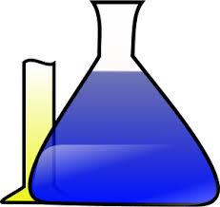
You’ve likely used the scientific method in your everyday life without even knowing it. As we grow to adulthood, we become more skilled at applying reason to learn about our world and to solve problems.

The scientific method has been practiced in one form or another for more than a thousand years. In fact, because science builds on previous knowledge, it is thanks to the application of the scientific method by our ancestors that we now have iPods, computers, video games, cars, planes, etc.

So how do we use the scientific method? Let’s go through the steps. These steps are intended to eliminate bias. Bias is when a person lacks a neutral point of view and wants to find a particular answer. All people have biases, which isn’t always bad, but we try to eliminate bias in science.

Step #1 is Ask a Question. The question will usually relate to a specific observation. “Why is the sky blue?” “Does sound travel faster in air than in water?”

Step #2 is Research the Topic. Has your question already been answered? If not, what do we know about your question and observations that might help you answer and explain them? Science builds on the work of others, so don’t hesitate to take what you can from previous experiments.

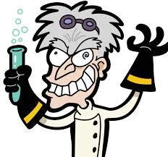
Step #3 is Make a Hypothesis. A hypothesis is simply a guess of what the answer to your question is. A hypothesis can be anything as long as it might explain the observations that led to your question.

Step #4 is Conduct an Experiment. This is where you get to have fun and be creative! You get to design your own experiment and perform it in your own way as long as you follow some guidelines we will learn more about later.

Step #5 is Collect Data and Analyze It. As you perform your experiment, you will make many measurements and observations, which together are called data. Analyze data and learn all that you can from them using your reasoning.

Step #6 is Make a Conclusion. Based on your data and analysis of the data, you will either find that your hypothesis was right, that is wasn’t right, or that it might be right but more experimenting is needed.

Step #7 is Report. What good are your findings if you don’t tell others about them? Let others take what you’ve learned and build on it. Together, we push human knowledge and understanding forward!

