Name _____________________________________

Guided Notes: Science Skills

1. What is an observation?

2. What is an inference?

3. Give an example of an observation you have made today.

4. Give an example of an inference you’ve made today.

5. Competition! Watch the video clip, make as many inferences as you can and write them down.

Many people do experiments. Unfortunately, many people perform experiments incorrectly, as in the following example:

Jack Sparrow wants to know which sails will make the Black Pearl, his pirate ship, sail the fastest. He tests three different types of sails: His usual sails, 100% cotton sails, and 100% polyester sails.

In the evening, he sails from Tortuga to Pelegosto using his regular sails. It takes him three hours. The next morning, he sails from Pelegosto back to Tortuga using the 100% cotton sails. It takes him eight hours. Then, in the afternoon, he sails from Tortuga back to Pelegosto using the 100% polyester sails. It takes him two hours and fifty-nine minutes.

6. Jack Sparrow cannot conclude that the 100% polyester sails make his ship the fastest. Explain one reason why.

7. Explain another reason why.

8. Explain yet another reason why (wow, rough day for Jack!).

9. Why can you only have one independent variable in an experiment?

10. Why does an experiment need a control group?

Henry notices that his shower is covered in a strange green slime. His friend tells him that coconut juice will get rid of the green slime. Henry decides to check this out by spraying half of the shower with coconut juice every morning. He sprays the other half of the shower with water each morning. After 3 days, there is no change in the appearance of the green slime on either side of the shower.

Answer #11-14 with the following choices:
A. The appearance of the slime after 3 days
B. What type of liquid the shower was sprayed with (coconut juice or water)
C. The side of the shower that was sprayed with coconut juice
D. The side of the shower that was sprayed with water

11. What is the independent variable?

12. What is the dependent variable?

13. What is the control group?

14. What is the treatment group?
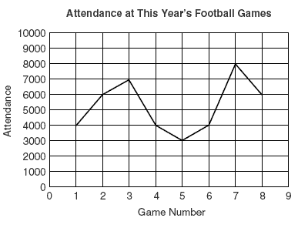 | 15. Which game of the season had the best attendance?  16. Which game of the season had the worst attendance?  17. How many more people attended the best-attended game than the worst-attended game?

